Day 16&17 - Task07 - Git&Github02

1. Install Git
Step 1
Download Git from
- Git Official Website
Click Download for Windows
Install with default settings.

Step 2
Open Git Bash
Check installation.
git --version
Example
git version 2.50.1.windows.1
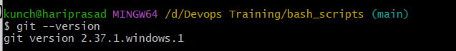

Configure Git (Only once)
Tell Git who you are.
git config --global user.name "Your Name"
Example
git config --global user.name "Venugopal"
Set Email
git config --global user.email "yourmail@gmail.com"
Verify
git config --global –list
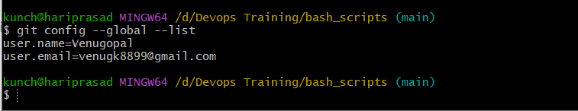

2. Create Repository in GitHub
Go to
- GitHub
Click
New Repository
Repository Name
git-practice
Check
✅ Add README.md
Choose
.gitignore
Example
Node
or
None
Click
Create Repository
Repository created successfully.

3. Clone Repository
Copy repository URL
Example
https://github.com/username/git-practice.git
Open Git Bash
Go to folder
cd D:
or
cd "D:/Devops Training"
Clone
git clone https://github.com/venugh8899/git-practice.git
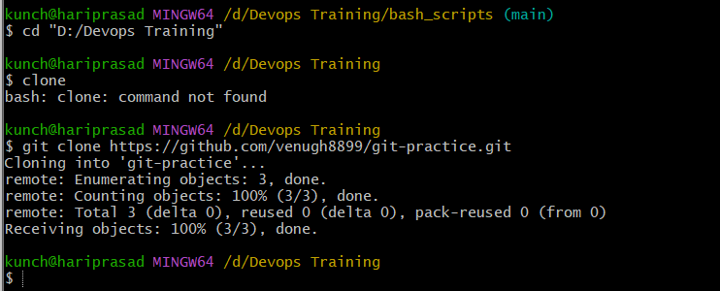

Output
Cloning into 'git-practice'
Move inside repository
cd git-practice

4. Create Two Files
touch file1.txt
touch file2.txt
Windows alternative
echo Hello > file1.txt
echo Git > file2.txt
Check
dir
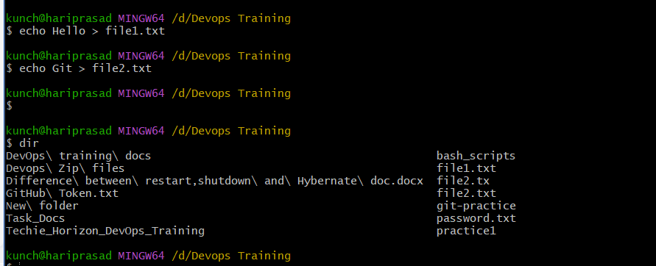

5. Commit Two Files
Check status
git status
Add files
git add .
Commit
git commit -m "Added two files"
Push
git push origin main

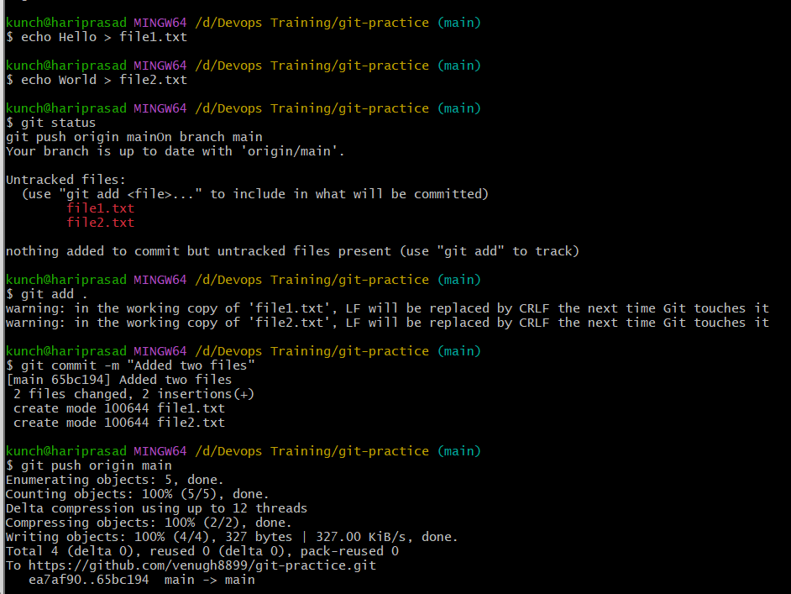

6. Create Local Branch
Create branch
git branch feature1
Move to branch
git checkout feature1
or
git switch feature1
Create file
echo Feature > sample.txt
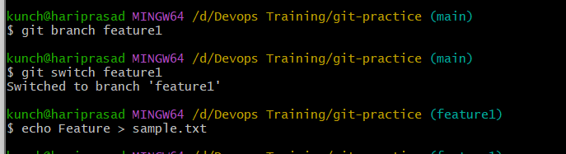
Commit
git add .
git commit -m "Added sample file"
Push
git push origin feature1
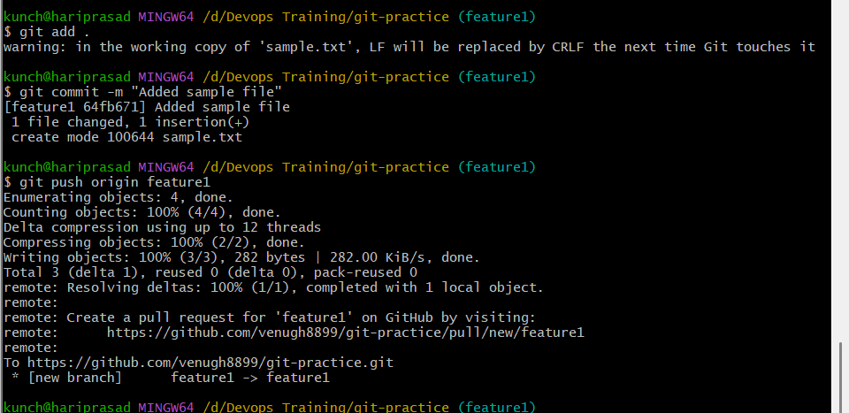

7. Create Branch in GitHub
Go to repository
Click
main ▼
Type
feature2
Click
Create branch
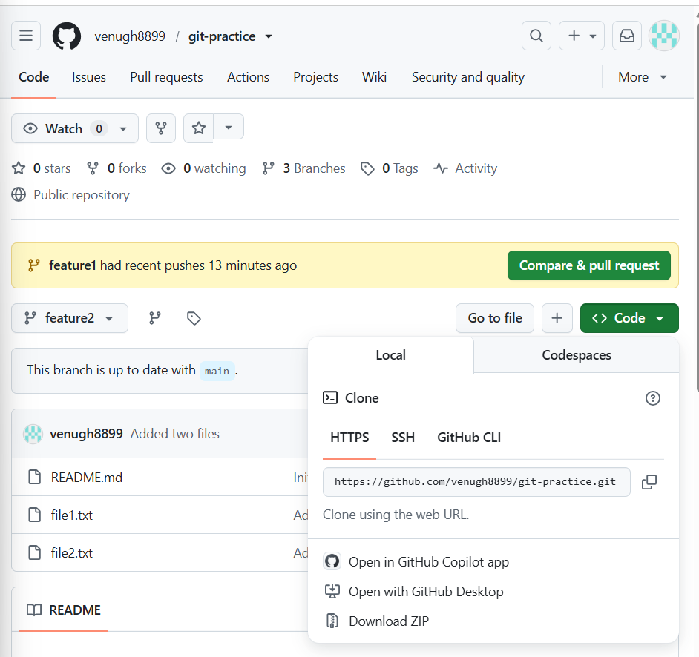

Clone Only That Branch
git clone --branch feature2 https://github.com/ venugh8899/git-practice.git
or
git clone -b feature2 https://github.com/venugh8899/git-practice.git

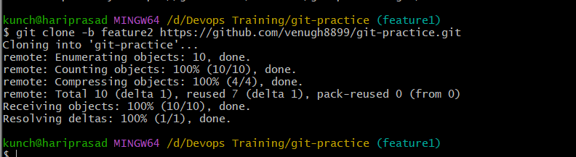

8. Merge Local Branch into Main
Go to main
git checkout main
Merge
git merge feature1
Push
git push origin main
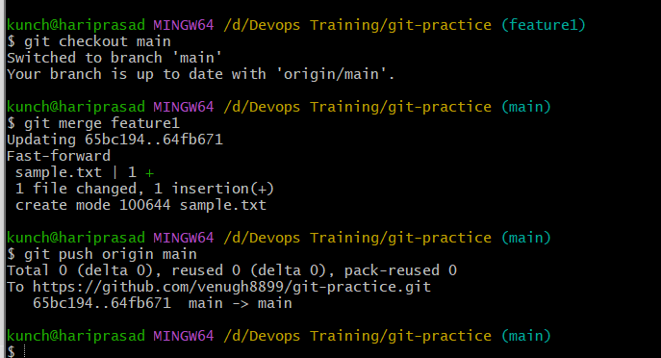
9. Merge GitHub Branch Using Pull Request
Push branch first
git push origin feature2
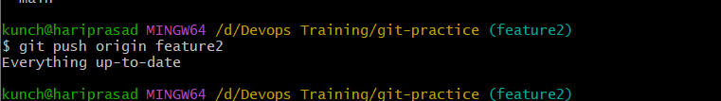
Go to GitHub
Click
Compare & Pull Request
Review
Click
Create Pull Request
Click
Merge Pull Request
Delete branch if needed.

10. Push New File to Branch
Switch branch
git checkout feature2
Create file
echo Demo > demo.txt
Commit
git add .
git commit -m "Added demo file"
Push
git push origin feature2
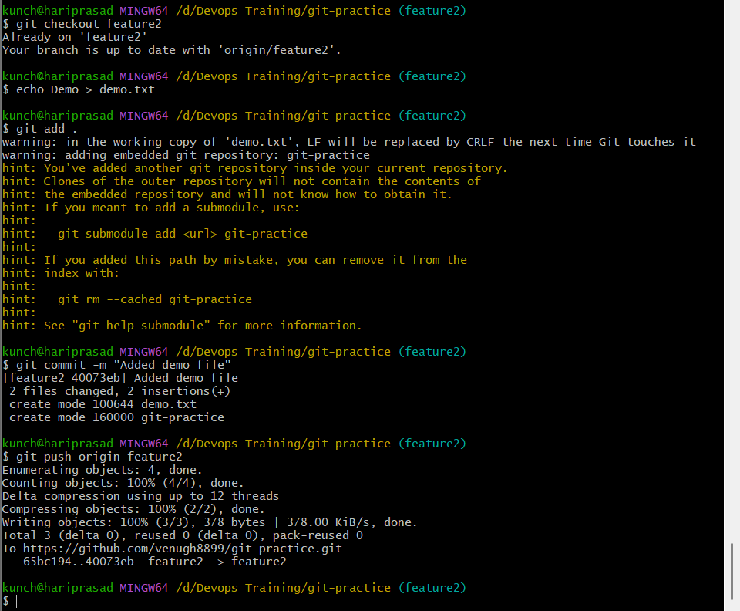

11. Clone Only One Branch
git clone --single-branch --branch feature2 https://github.com/venugh8899/git-practice.git git-practice-feature2
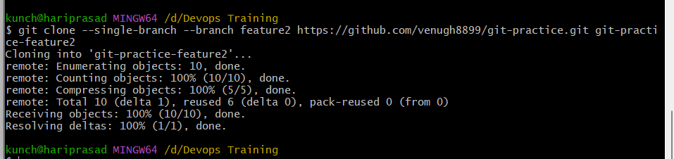

12. Ignore Password File
Create file
echo Password123 > passwords.txt
Open
.gitignore
Add
passwords.txt
Now Git ignores it.
Check
git status
passwords.txt will not appear.
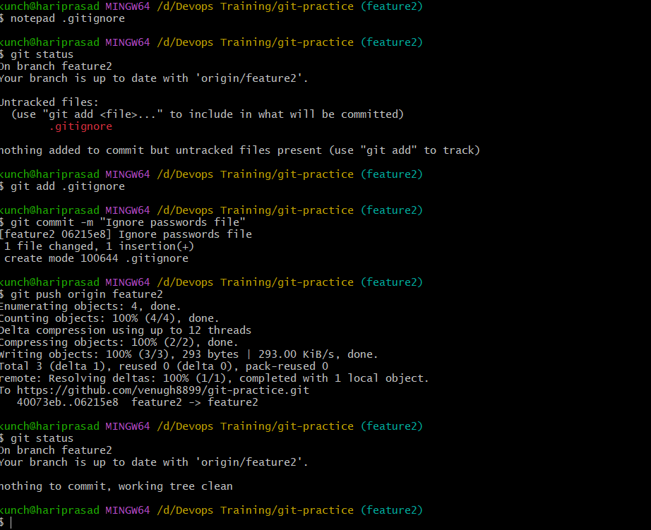

13. Reset Last Commit (Keep Changes Unsaved)
Step 1: Create a new file
echo "This is a reset demo" > reset-demo.txt
Step 2: Stage it
git add reset-demo.txt
Step 3: Commit it
git commit -m "Reset demo commit"
Check the log:
git log --oneline -2
Example:
a1b2c3d Reset demo commit
06215e8 Ignore passwords file

Step 4: Reset the last commit
git reset --mixed HEAD~1
Git will remove the commit but keep the file.
Run:
git status
Expected output:
Untracked files:
reset-demo.txt
or, if it was already tracked:
Changes not staged for commit:
modified: reset-demo.txt
✔ Commit removed
✔ Changes remain unstaged
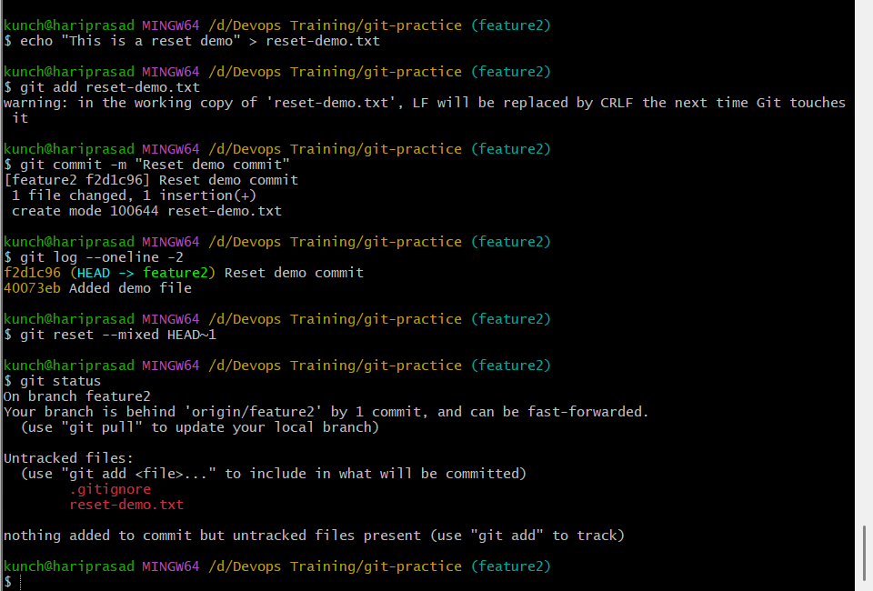

14. Revert Commit
If already committed
git log
Copy commit id
Example
8ac4d52
Run
git revert 8ac4d52
Push
git push
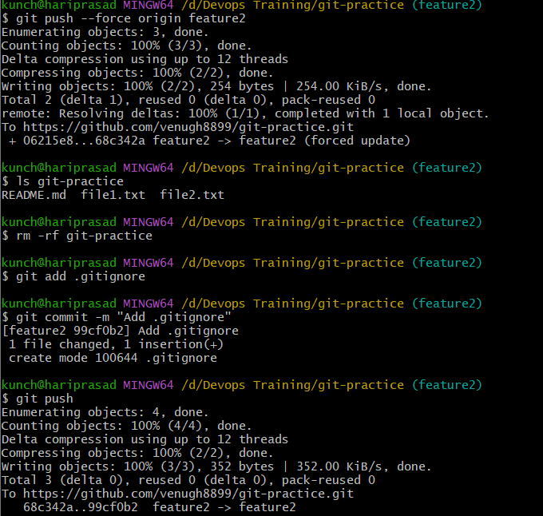

15. Stash Changes
Suppose editing
test.txt
Store changes
git stash
Now work on another file.
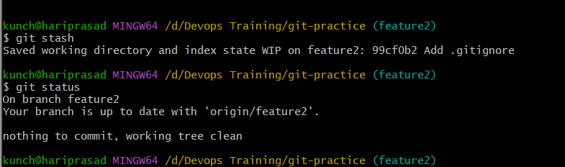

16. Restore Stash
View
git stash list
Recover
git stash pop
or
git stash apply
Difference
apply → Keeps stash
pop → Removes stash
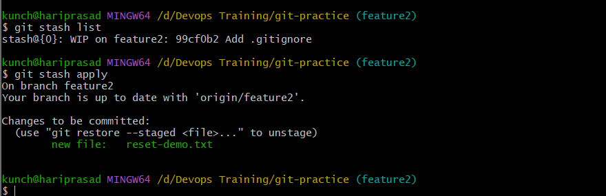

17. Generate SSH Key
Generate
ssh-keygen -t ed25519 -C "yourmail@gmail.com"
Press
Enter
Enter
Enter
Copy public key
cat ~/.ssh/id_ed25519.pub
Copy complete output.
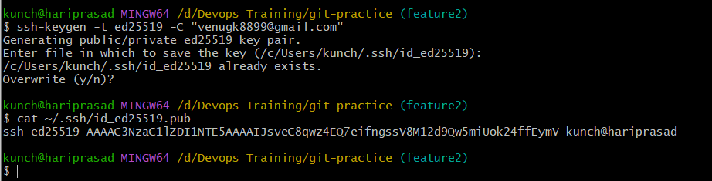

Add SSH Key to GitHub
GitHub
Settings
↓
SSH and GPG Keys
↓
New SSH Key
Paste key
Save
Test
ssh -T git@github.com
Expected
Hi username!
You've successfully authenticated.
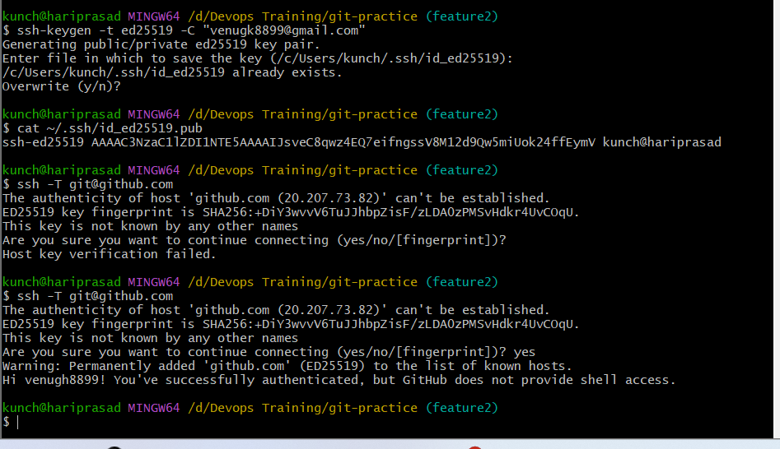

18. Configure GitHub Webhook
Repository
↓
Settings
↓
Webhooks
↓
Add Webhook
Payload URL
Example
http://your-server:8080/github-webhook/
Content Type
application/json
Choose
Just push events
Save.

19. What is .git Folder?
Check
ls -la
Shows
.git
Inside
cd .git
Contains
objects/
refs/
HEAD
config
hooks
logs
index
Purpose
Folder | Purpose
objects | Stores commits
refs | Branches
HEAD | Current branch
config | Repository settings
hooks | Automation scripts
logs | Git history
index | Staging area
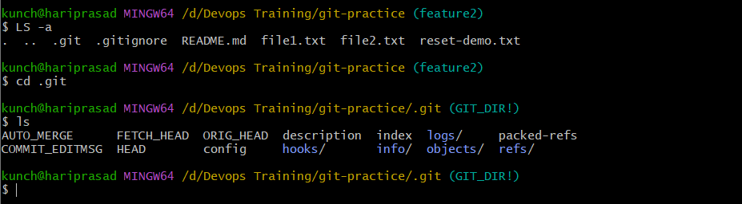

20. Check Logs
Simple
git log
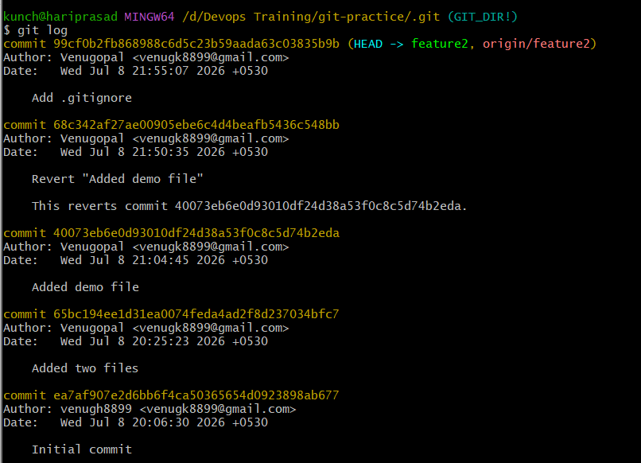
One line
git log –oneline
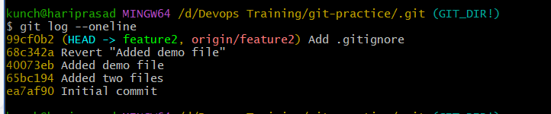

Graph
git log –graph
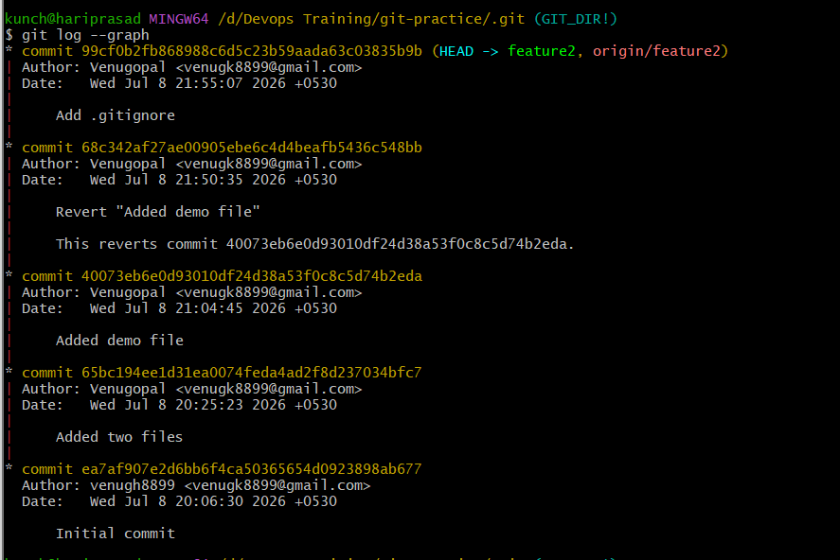
Detailed
git log –stat
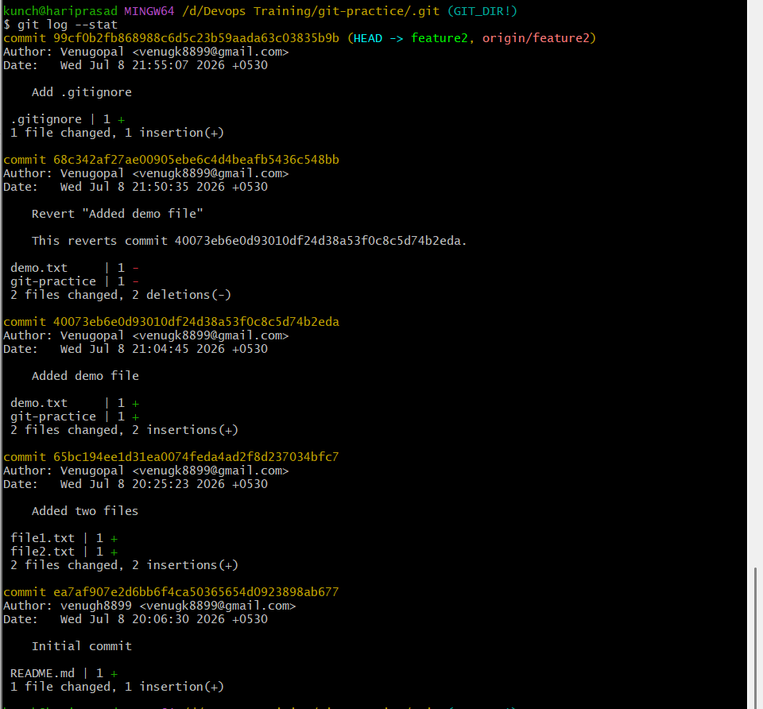
21. Rename Commit Message
Latest commit
git commit --amend -m "New commit message"
If already pushed
git push --force
(Be careful with --force when collaborating.)
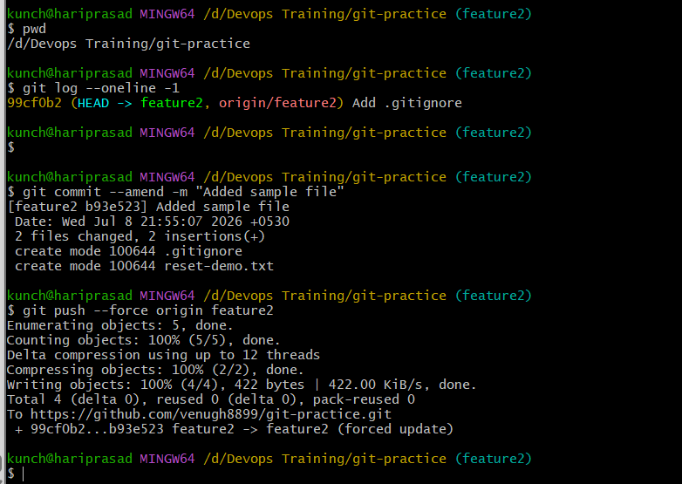

22. Merge Multiple Commits into One (Squash)
Example
Last 3 commits
git rebase -i HEAD~3
Editor opens
pick
pick
pick
Change to
pick
squash
squash
Save
Edit final commit message
Save
Done.
Push
git push –force

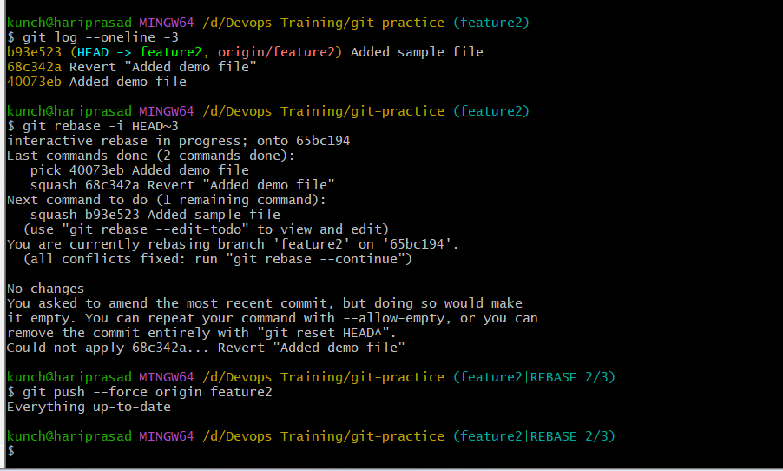

Most Common Git Commands (Cheat Sheet)
Command | Purpose
git init | Initialize repository
git clone URL | Clone repository
git status | Check status
git add . | Stage all files
git commit -m "msg" | Commit changes
git push origin main | Push to GitHub
git pull | Get latest changes
git branch | List branches
git checkout branch | Switch branch
git switch branch | Switch branch (new syntax)
git merge branch | Merge branch
git log --oneline | View compact commit history
git stash | Temporarily save changes
git stash pop | Restore stashed changes
git reset --mixed HEAD~1 | Remove last commit, keep changes
git revert <commit-id> | Create a new commit that undoes a previous one
git commit --amend | Modify last commit
git rebase -i HEAD~3 | Squash multiple commits

